

NCICB

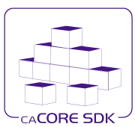
caCORE SDK
Build Process Detail Design

Version No: 1.2
Last Modified: 07/12/2006

Author: Satish Patel
Team: caCORE SDK
Client: National Cancer Institute - Center for Bioinformatics,
National Institutes of Health,
US Department of Health and Human Services

This document was prepared for
NCI Center for Bioinformatics, pursuant to the caCORE Software Development Kit (SDK)
Enhancement project.(REF: Solicitation No. S06-234).

Document History

Document Location
The most current version of this document is located in CVS under cacoresdk/Project/SDK v3.2/Development/Design.

Revision History
Version Number | Revision Date | Author | Summary of Changes
1.0 | 07/10/06 | Satish Patel | Initial Draft
1.1 | 07/11/06 | Daniel Dumitru | Formatting, Grammatical Revisions
1.2 | 07/12/06 | Satish Patel | Incorporated review comments

Review
Name | Team/Role | Version | Date Reviewed | Reviewer Comments
1.0 | Dan Dumitru  Charles Griffin | 1.0 | 07/11/2006 | See the document review form

Related Documents
More information can be found in the following related documents:

Document Name

Table of Contents
Document History 2
0.1 Document Location 2
0.2 Revision History 2
0.3 Review 2
0.4 Related Documents 2
Table of Contents 3
Table of Figures 4
1. Introduction 5
1.1 Purpose 5
1.2 Intended Audience 5
1.3 Scope 5
1.4 Definitions, Acronyms, and Abbreviations 5
2. Build Process Detail Design 6
2.1 Problem Scenario 6
2.1.1 Current Directory Structure 6
2.1.2 Current Build Process 6
2.2 Package Requirements 7
2.3 Dependencies 8
2.4 Proposed Solution 8
2.4.1 Proposed Directory Structure 8
2.4.2 New Build Process 8
2.4.3 Customization Option under New Build Process 9
3. Configuration/Deployment Considerations 11
3.1 Property/Configuration Files 11
3.2 Deployment Considerations 11

Table of Figures

Figure 1: Current Directory Structure 6
Figure 2: Current Output Directory Structure 7
Figure 3: Proposed Directory Structure 8
Figure 4: Example of Output Package Directory Structure 9
Figure 5: Example of Directory Structure for Customization of Generated System 10

Introduction

Purpose
The purpose of this document is to describe the deficiency of the existing build process and how the proposed build process improves it.

Intended Audience
The intended audience for this document includes Developers, Administrators, and System Integrators interested in the obtaining an overview of the SDK build process.

Scope
The scope of this document is to describe the limitations of the existing build process and to describe the new build process.

Definitions, Acronyms, and Abbreviations
All definitions, acronyms, and abbreviations are provided in the centralized definition document found at cacoresdk/Project/SDK v3.2/Miscellaneous/Acronyms.doc.

Build Process Detail Design

Problem Scenario

Current Directory Structure
The current code base structure of the caCORE SDK application is shown below:
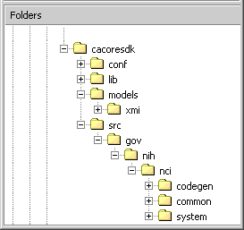
Root folder
Configuration files folder
Libraries folder
XMI file folder
Java Source Codebase
Figure 1: Current Directory Structure

In the current code base, the conf folder is used to hold files of all types that are used in the HTTP interface, code generation configuration, database configuration, and deployment settings. The lib folder contains java libraries to be used by the SDK itself and to be used by the generated application components. The src folder contains the source code of the generated system as well as the source code used by the code generation module of SDK.

Problems with the Current Directory Structure
The conf folder should ideally contain only the files required for configuring the project for build time and deployment time. However the conf folder contains files for the web interface of the application, readme file, license text, DTDs etc. Having all these files without a directory structure makes it difficult for the developer to locate the required files. Other files needed by the build process are located under the project root folder. These files should be placed under a separate directory so that one can easily access or ignored.

Current Build Process
The current build process has been divided into multiple build scripts with a lot of options to customize the process itself. The user of the script can enable or disable any particular target by means of switching the flag inside the property file. The build process generates two different packages; one for the server side, and another for the client side.
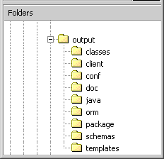
Output folder
Compiled classes of generated java files
Configuration files of generated system
Java docs
Generated Java beans
Generated OR mapping files
Generated packages folder
Generated XSD schemas
Compiled JET templates
Figure 2: Current Output Directory Structure

Before generating the packages, the build process creates various folders as shown above in which it puts the files generated as part of the code generation process. Each type of generated file is placed in a different directory. These intermediate directories are subsequently used to create the final packages for distribution.

Problems with the Current Build Process
The current build process contains many different options to choose from. However the entire list of options makes the build process cumbersome and difficult to follow. Since the SDK generated files are scattered over various directories, they can not be readily utilized by other application developers to modify and build the application. In order to effectively modify and rebuild the generated application, the application developer has to reorganize the generated artifacts, and create a corresponding build script.

Also, the current build process forces the SDK users to know the steps of how the SDK internally generated the application from the XMI file. Users of the SDK should be able to focus on their own application development and avoid learning the SDK build process.

Package Requirements
Currently, the following three types of packages need to be created:

- war package
The war package is to be used inside the application server container. A war package has to follow the specific structure specified by the Servlet specification from Sun Microsystems.

- client-jar package
The client-jar package should contain all of the files and resources that are required to access the server using the Spring Remoting client.

- thick-jar package
The thick jar is a package to be used by another application inside the application server container. It should contain everything that the application needs to access the SDK generated system. In other words, the thick client should expose the application service interface through which the client application will invoke the SDK generated system without going outside the application server container. The thick-client jar will be a part of the “lib” folder of the application where other libraries used by the application reside. The thick client should be able to load the required resources from the classpath as needed.

Dependencies
The caCORE API and other projects use the SDK build process to build their application. If the SDK build process changes, these projects will have to change their build process also.

Proposed Solution

Proposed Directory Structure

The proposed directory structure will allow the users of the SDK to easily identify and maintain the configuration files and build scripts.

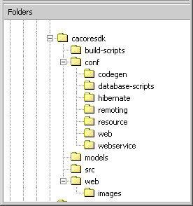
Root folder
Build Scripts and property files (new)
Code generation configuration (new)
Database scripts of generated sys (new)
Hibernate config of generated sys (new)
Remoting config of generates sys (new)
Resources like readme, licence etc (new)
Web config files of generated sys (new)
WS config files of generated sys (new)
Input models
Source code of SDK
HTTP interface files of the generated sys (new)
Figure 3: Proposed Directory Structure

New Build Process

The new build process will have very few but useful options to build the application from the XMI file. With the limited options available to the users to build the system, users will not have to learn how the build process of SDK works and as a result usability of the SDK will also improve.

The new build process will be organized as a series of three step processes for every type of package that is being generated. In the first step, the folder for the package type will be created, which will contain the source code from which the package can be created. In the second step, the custom code will be copied over the generated package source code. Finally, the individual package build scripts will be invoked to create particular package.

Currently, the following three types of package need to be created:

- The .war file to be used in the application server.
- The .jar file to be used by the Java Client environment.
- The .jar file to be used by the client applications that wants to use the generated system inside the application server container.

Below is an example of how the directory for a particular package type will look like.
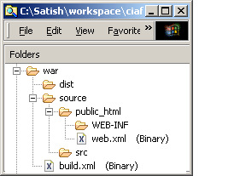
Root folder for package type
Distribution folder for package type
Source folder of package
Web content folder for package
Java Source code folder
Build script to create distributable file
Figure 4: Example of Output Package Directory Structure

As part of the build process, a separate directory will be created for the .war package type as shown above. The package directory will have two folders, source and dist, as well as a corresponding build script. The src folder will contain the source code required to create the distributable .war package. The build script will be utilized to create the distributable .war package.

As the package source code is available to the users, they will be able to modify the source code by hand if they want to do so. Also, the developers will be able to debug the application as needed as the source code becomes easily available. If the developer chooses to regenerate the system, all contents of the output folder will be overwritten.

Customization Option under New Build Process
If the application developer wants to customize the build process such that files needed by their application are woven inside the generated application, he/she will be able to do so very easily under the new build process. In order to customize a particular package, the user will have to create a package structure that parallels the output folder, as shown below:

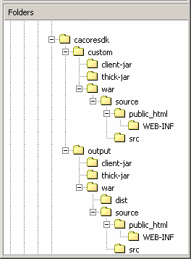
Project root folder
Custom code folder
.war custom code folder
Output folder
.war output folder
Figure 5: Example of Directory Structure for Customization of Generated System

Everything that the user of the SDK wants to be customized will be kept in the custom package folder. The custom content can be a java library, a configuration file, or java source code. All the contents of the custom package folder will be copied to the output package folder. If another file with the same name exists inside the output package folder, it will be overwritten. By using this process, the developer will not have to know any other internal details of the SDK build process.

Configuration/Deployment Considerations

Property/Configuration Files
New (*) or Modified (#) | File Location | File Name | Description of Change
# |  | build.xml | Restructure file as outlined in Section 2.4.2.
# |  | build.properties | Restructure file as outlined in Section 2.4.2.
# | conf | deploy.properties | Restructure file as outlined in Section 2.4.2.
# | conf | *.* | All files under conf folder to be restructured as mentioned in Section 2.4.1.

Deployment Considerations
N/A

